Urine and droppings
Take precautions before and during clean up of rodent-infested areas. Before cleaning, trap the rodents and seal up any entryways to ensure that no rodents can get in. Continue trapping for a week. If no rodents are captured, the active infestation has been eliminated and enough time has passed so that any infectious virus in the rodent's urine/droppings or nesting material is no longer infectious.
Before starting clean up of the space, ventilate the space by opening the doors and windows for at least 30 minutes to allow fresh air to enter the area. Use cross-ventilation and leave the area during the airing-out period.

First, clean up any urine and droppings
When you begin cleaning, it is important that you do not stir up dust by sweeping or vacuuming up droppings, urine, or nesting materials.
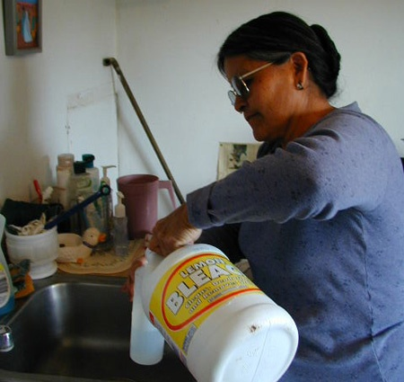
Woman preparing bleach solution of 1 part bleach to 10 parts water.
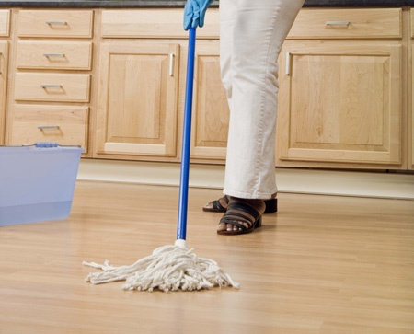
Mopping with disinfectant
- Wear rubber, latex, or vinyl gloves when cleaning urine and droppings.
- Spray the urine and droppings with a disinfectant or a mixture of bleach and water and let soak 5 minutes. The recommended concentration of bleach solution is 1 part bleach to 10 parts water. When using a commercial disinfectant, following the manufacturer's instructions on the label for dilution and disinfection time.
- Use a paper towel to pick up the urine and droppings, and dispose of the waste in the garbage.
- After the rodent droppings and urine have been removed, disinfect items that might have been contaminated by rodents or their urine and droppings.

Next, clean and disinfect the whole area
- Mop floors and clean countertops with disinfectant or bleach solution.
- Steam clean or shampoo upholstered furniture and carpets with evidence of rodent exposure.
- Wash any bedding and clothing with laundry detergent in hot water if exposed to rodent urine or droppings.
Lastly, remove gloves, and thoroughly wash hands with soap and water (or use a waterless alcohol-based hand rub when soap is not available and hands are not visibly soiled).

Dead rodents or nests
Wear rubber, latex, or vinyl gloves when cleaning up dead rodents or nests.
- Spray the dead rodent or nest and the surrounding area with a disinfectant or a mixture of bleach and water.
- Soak rodent, nesting materials or droppings in solution for 5 minutes before wiping up with a paper towel or rag.
- Place the dead rodent or nesting materials in a plastic bag and seal tightly. Place the full bag in a second plastic bag and seal.
- Throw the bag into a covered trash can that is regularly emptied.
Remove gloves, and thoroughly wash hands with soap and water (or use a waterless alcohol-based hand rub when soap is not available and hands are not visibly soiled).

Cabins, sheds, barns, or other outbuildings
Before attempting to clean cabins, sheds, barns, or other outbuildings, open all doors and windows for 30 minutes. This will allow fresh air to enter the work area.
- Wear rubber, latex, or vinyl gloves and clean up all rodent urine, droppings, nests, and dead rodents using disinfectant or mixture of bleach and water.
- Mop floors or spray dirt floors with a disinfectant or mixture of bleach and water.
- Clean countertops, cabinets, and drawers with a disinfectant or a mixture of bleach and water.

Attics, basements, crawlspaces, and other storage areas

Recommended methods of textile decontamination

Clothing, Bedding, Stuffed Animals
Launder potentially contaminated bedding, clothing, or stuffed animals with hot water and detergent. Use rubber, latex, vinyl, or nitrile gloves when handling contaminated laundry. Machine-dry laundry on a high setting or hang it to air dry in the sun.
Laundry detergent breaks down the virus's lipid envelope, rendering it harmless. Additionally, heat generated by the clothes dryer will also ensure that the virus is noninfectious. However, the use of a clothes dryer alone is not recommended as the sole treatment because not all dryers reach the necessary temperature. A temperature of 45 degrees Celsius, or about 115 degrees Fahrenheit, is required to inactivate hantaviruses.

Carpets/Furniture
Shampoo rugs and upholstered furniture with a commercial disinfectant or with a commercial-grade steam cleaner or shampoo.

Books, Papers and other Non-washable items
You may leave books, papers, and other items that cannot be cleaned with a liquid disinfectant or thrown away, outdoors in the sunlight for several hours, or in an indoor area free of rodents for approximately 1 week before cleanup. After that time, the virus should no longer be infectious. Wear rubber, latex, vinyl, or nitrile gloves and wipe the items with a cloth moistened with disinfectant.
Once excreted into the environment by the rodent, hantaviruses can survive in the environment and remain infectious for a period of 2-3 days. Ultraviolet rays in sunlight inactivate hantaviruses.
Before cleaning attics, basements, crawlspaces and other storage areas, it is necessary to completely remove the existing rodent infestation by trapping. When there is no evidence of infestation, wait about 5 days before beginning to clean these areas. Before cleaning the space, ventilate the area by opening the doors and windows for at least 30 minutes to allow fresh air to enter the area and to remove potentially contaminated air from the area. Use cross-ventilation and leave the area during the airing-out period.
When cleaning attics, basements, crawlspaces and other storage areas:
- Wear rubber, latex, or vinyl gloves when cleaning up urine, droppings, or nesting materials. Note that a dust mask may provide some protection against dust, molds, and insulation fibers, but does not protect against viruses.
- Spray any urine, droppings, and nesting materials with either a bleach and water solution (1 parts bleach to 9 parts water) or a household disinfectant prepared according to the label instructions for dilution and disinfection time. Soak well. This will inactivate any virus. Use a paper towel or rag to pick up the materials and dispose of them.
- Mop floors after spraying them using bleach/water solution or a disinfectant. Dirt floors can be sprayed with either bleach and water solution or a disinfectant.
- If exposed insulation has become contaminated with urine and droppings, it should be placed into plastic bags for removal.
- To remove any potentially contaminated materials from storage vessels/boxes:
  - First, move the storage vessels/boxes outside and place them in an area that is well-ventilated and exposed to direct sunlight. The outside of the storage vessels/boxes can be disinfected using bleach and water solution or disinfectant solution;
  - Next, remove the potentially contaminated materials while in the sunlit, ventilated area. Remain upwind so that any dust or debris is not blown toward your face. Some contaminated stored materials, such as clothing, books, etc. can be decontaminated by following the recommended methods of disinfection provided in the table below; items that are no longer needed can be discarded.
- Dispose of any cardboard boxes contaminated with urine or droppings. Plastic, glass, or metal containers can be disinfected by spraying with the bleach and water solution or disinfectant. Then, using a rag or paper towel, wipe up the urine or droppings and dispose of the waste.
- Clean countertops, cabinets, and drawers with disinfectant or bleach and water solution.
- Decontaminate gloves with disinfectant or bleach and water solution. Wash hands well with soap and warm water.

Heavy rodent infestation
Special precautions should be used for cleaning homes or buildings with heavy rodent infestation. The special precautions may also apply to vacant dwellings that have attracted large numbers of rodents and to dwellings and other structures where hantavirus has been confirmed in the rodent population.
Workers who are either hired specifically to perform a clean-up or are asked to do so as part of their work activities should contact their local or state health department, local or state occupational health and safety authority (OSHA) or CDC for information about preventing rodent-borne diseases.
Persons involved in the clean-up of heavy rodent infestations should wear the protective equipment listed here:
- coveralls (disposable, if possible);
- rubber boots or disposable shoe covers;
- rubber, latex, or vinyl gloves;
- protective goggles;
- and an appropriate respiratory protection device, such as a half-mask air-purifying (or negative-pressure) respirator with a high-efficiency particulate air (HEPA) filter or a powered air-purifying respirator (PAPR) with HEPA filters. Follow local and state requirement regarding pulmonary function and fit testing before beginning any work requiring the use of a respirator.
- Personal protective gear should be decontaminated upon removal at the end of the day. All potentially infective waste material (including respirator filters) from clean-up operations that cannot be burned or deep-buried on site should be double-bagged in appropriate plastic bags. The bagged material should then be labeled as infectious (if it is to be transported) and disposed of in accordance with local requirements for infectious waste.

Air ducts (heating and cooling ventilation systems)
When there is evidence that rodents have access to heating and cooling ventilation systems, it is best to contact a professional rodent exterminating service to remove them. Companies specializing in duct cleaning are familiar with the particular problems and risks associated with rodent infestation in ventilation systems.
For more specific information on eliminating rodent infestations in heating and cooling ventilation systems and the companies that perform this service, refer to the Environmental Protection Agency's website.

