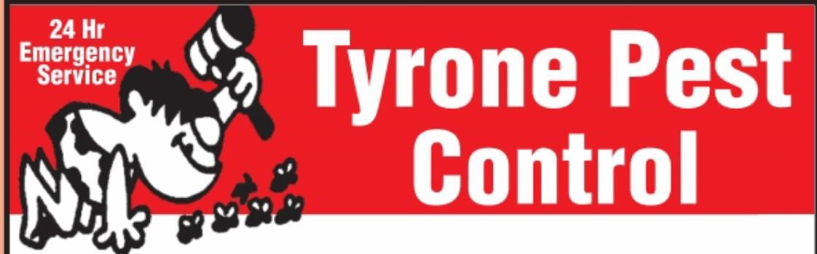
Residential Preparation Checklist for Cockroach Service

- You must be out of the apartment/house for a minimum of 6 hours.
- Open windows for 20 minutes after re entry if possible.
- Infants under 4 years of age, pregnant women and people suffering from heart, kidney, respiratory ailments, or allergies should remain away for at least 24 hours.
- We will be doing two treatments. The second treatment will be done within 10-15 days.
- If you’re still seeing live bugs 2 weeks after the second spray, contact us to arrange a third one.

KITCHEN
- Remove all items (dishes, glassware, utensils, food, cleaning supplies, etc.) from cabinets and storage areas.
- Place all opened food (cereals, crackers, cookies, sugar, flour, spices, canisters, etc.) in the refrigerator or sealed in plastic bags.
- Items from above may be placed on tabletops and covered with a sheet.
- Empty all trash cans. Remove paper grocery bags from kitchen area.
- Wash down all cabinets and shelving and vacuum crevices around shelving to remove food debris.

BATHROOM
- Remove all items from medicine cabinets.
- Remove all items from storage cabinets and drawers.
- Place all personal items (toothbrushes, toothpaste, cosmetics, toiletries, medications, etc.) in sealed plastic bags. These bags may be placed in the bathtub along with other stored items. Keep floor areas clear.

BEDROOM
- Move all items from closet floor areas and closet shelving.
- Remove dresser drawers.
- Items may be stacked on beds and covered. Keep floor areas clear.

PETS
- Arrange to have pets vacated for at least four hours.
- Fish tanks must be covered and sealed with plastic. Pumps must be turned off for at least four hours.
- Pet food dishes should be empty, clean and covered.
- Birds and reptiles must be removed from the structure.

TYRONE PEST CONTROL
520 Pearson Court
Prince Albert, Saskatchewan
S6V 6C6
Phone: 306-764-4800
Fax: 306-764-0057
Email: tyrone@tyronepestcontrol.com

